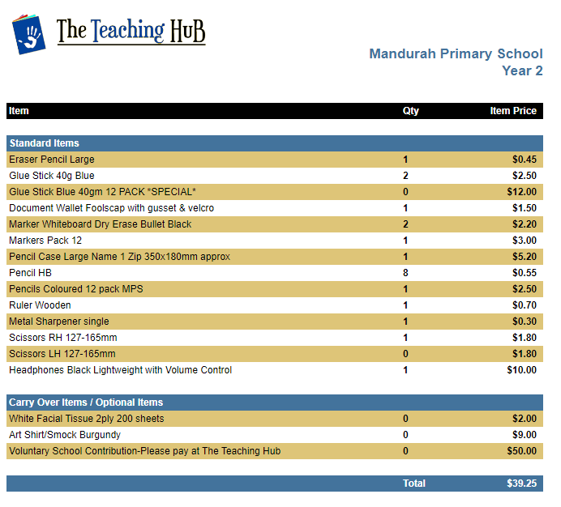

Please order online at:

[**https://booklists.theteachinghub.com.au**](https://aus01.safelinks.protection.outlook.com/?url=https%3A%2F%2Fbooklists.theteachinghub.com.au%2F&data=05%7C02%7CCarolyn.Murray2%40education.wa.edu.au%7C961756f484424865bf5008dce5c06cd3%7Ce08016f9d1fd4cbb83b0b76eb4361627%7C0%7C0%7C638637861865195023%7CUnknown%7CTWFpbGZsb3d8eyJWIjoiMC4wLjAwMDAiLCJQIjoiV2luMzIiLCJBTiI6Ik1haWwiLCJXVCI6Mn0%3D%7C0%7C%7C%7C&sdata=e22h4R9lgIOLZ3srJr1%2BjTrdVbSETWdpIkkDLzEqiTY%3D&reserved=0)

or in store:

**Unit 1/58 Reserve Drive Mandurah WA 6210**